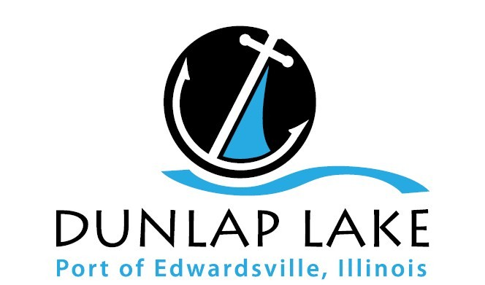
Dunlap Lake Property Owners Association
Annual Meeting Summary, February 15, 2018

The members met at 7 p.m. at the Moose Lodge, 7371 Marine Road in Edwardsville. President Alan Ortbals welcomed everyone and called the meeting to order. The existing officers were introduced and retiring board members James Seubert and Mark Hicks were thanked for their service.

- Five board members were elected to 3-year terms: Eric Ham, Andy Leek, Craig Louer, Andrew Reznak and Roy Wehling.

- Treasurer Rick Welle gave the FY2017 financial report (March 1, 2017 to February 28, 2018). Revenues of $180,000; Expenses of $120,000. The $60,000 for engineering for the dredge project was not spent due to failure of referendum.

- The Commons Committee reported that inflow on most of the commons areas are blocking up and many of the shorelines need repairs. The group is looking for ways to make improvements and possibly get grants for rain garden inflow instead of riprap because that is easier to maintain. They are also looking into building docks in high-need areas to maximize capacity.

- The Dam Maintenance Committee reported that the dam passed its annual inspection but has several new projects on the horizon. The drainage gate has broken off the overflow silo so planning is underway for a new gate about 5 feet below normal pool. Moving the gate up eliminates the threat of the lake emptying if an aging gate was to stick open.

The committee also reported that the Illinois Department of Natural Resources has notified the Association that the spillway capacity must be increased by 230 percent. Preliminary engineering is underway to develop an expansion plan and estimate costs, which IDNR has said will need to be implement over the next 10-15 years.

- The Silt Committee presented two part infrastructure development and lake maintenance plan.

- Part 1 – A ONE-TIME INFRASTRUCTURE DEVELOPMENT PROJECT that would:
  - Create a dewatering basin on the Fogle property at 840 East Lake including installation of piping that would be used to pump slurry into the basin and return clean water to the lake
  - Clean out the current silt retention basin at the south end of the lake; and dredge as much as possible out of Cove A, and the southern part of the lake, an estimated 30,000 cubic yards of material.
  - This would cost $1.75 million to be collected through an assessment based on property values. It is estimated that the assessment rate would be a property’s assessed value multiplied by 0.0065. This special assessment would run for 15 years until the loan is repaid. (Assessed value is set by the County and is usually one-third of market value.)

- Part 2 – INCREASED ANNUAL ASSESSMENT for silt removal on a pay-as-you-go basis
An on-going dredging project would remove material from other areas of the lake that would be funded by the regular, annual assessments on a pay-as-you-go basis. Additional improvements to the south end silt trap could be made if a grant is received. Annual assessment revenue would cover regular emptying and maintenance of the trap

PAGE 1 of 2 Important Information on the Back

- Treasurer Rick Welle presented a long-term capital maintenance plan that would address all of the needs presented by the committees. There are actually two budgets being presented this year:

- The first budget is essentially unchanged. Annual assessments would remain at $500/Voting Lot, producing annual revenue of approximately $180,000. It would not produce the funds needed to make the common area repairs and improvements, the needed repairs and improvements to the drainage silo or spillway, nor allow for dredging. The board does not recommend using this budget.

- The Board recommends a budget that would commit funds to capital development of the lake’s infrastructure. This will require an increase in annual dues to $1,000/Voting Lot with the additional revenue going into a major projects reserve fund. This money would be used for the common areas, the silo and spillway projects and dredging.

Both the proposed special assessment for the silt infrastructure and increased annual assessment must be approved by the membership. Because both are needed, they will be on one ballot. Passage will require 2/3 approval of the votes cast.

Board members responded to questions and many of those present at the annual meeting made comments. Alan announced that the board would mail out more information and that ballots would be mailed to all homes and the meeting was adjourned.

In response to questions at the meeting we wanted to explain that the funding structure was done this way for two reasons.

- To forge a compromise between those who think everyone should pay the same for major projects like dredging and those who think those with more expensive homes should pay more.
- To provide an on-going revenue steam to pay for continued dredging needed in other areas of the lake while building in flexibility if funds are needed for emergency or high priority situations that may occur. The proposed increase in assessments would allow an additional 30,000 to 50,000 cubic yards of material to be removed from the lake every two to three years.

A series of neighborhood meetings will be held so that property owners can ask questions and provide input.
Meeting dates, places and times will be mailed on postcards to your home.

Ballots will be mailed out in Mid March

